Creating an animation of a character by using 3DMAX and FrameAnimator

1. Creation of the model.
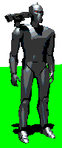
Make the 3D-model of the character in 3DMAX

2. Stage for creation of animation
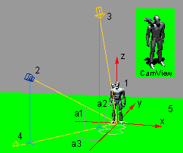
3D-scene
1 - Character
2 - Camera ('Orthographic Projection' (3DMAX))
3 - A light source for creation of a shadow (set 'Cast Shadows', use 'Ray-Traced Shadows', set 'Check Decay' switch to None (3DMAX))
4 - An any light source (set 'Check Decay' switch to None (3DMAX))
5 - One-colour plane for create background colour and shadow of character on the image
a1 - Angle of the camera (-25.7)
a2 - Angle of a light source for a shadow (-75.7)
a3 - Turning angle of the camera (-150, -90, -30, 30, 90, 150)

3. Generation of frames
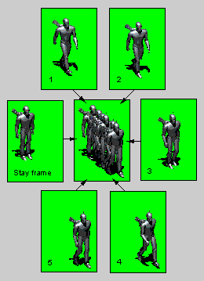
1,2,3,4,5 - package of animation for 'South East' direction (AB0000. BMP-AB0004. BMP). When creating the images do not use 'Anti-Aliasing' (3DMAX)
'StayFrame' does not included into a package 'AB', but included into a package 'AA'

4. Creation of the project of animation
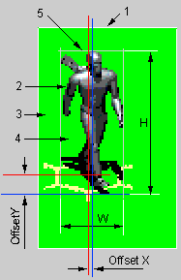
The frame
1 - actual dimensions of the image
2 - target image of the character
3 - empty edges (do not delete them manually. Set option 'Edit\Options\Autocutting', and FrameAnimator will cut off these edges before creation of a FRM-file)
4 - background (is interpreted, as transparent)
5 - the logic border of the frame (if an option 'Edit\Options\Autocutting' is not checket, the logic border coincides with actual dimensions of the image). For the different frames in a package of animation these dimensions are various.
H, W - height and width of the frame
OffsetX, OffsetY - the offsets of the logic centre (In FrameAnimator is values 'FramesOffset [direction] .X' and 'FramesOffset [direction] .Y')

5. Adjustment of animation
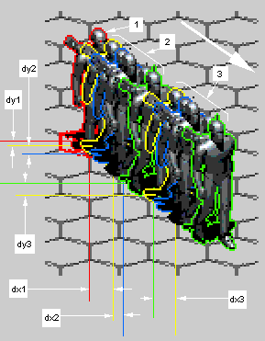
Tuning of animation
1 - the frame of the still character (does not included into animation of walking)
2 - frames of animation of walking
3 - repeat of animation of walking (repeats so long as the character will not reach the necessary place on a map)
dx1, dy1 - offsets of the first frame at the moment of a beginning of animation:
FirstOffset [direction] .X = FramesOffsets [direction] .X + FrameOffsets [direction] [1] .X
FirstOffset [direction] .Y = FramesOffsets [direction] .Y + FrameOffsets [direction] [1] .Y
dx2, dy2 - offsets of the next frame of animation. In FrameAnimator it is values 'FrameOffset [direction] [i] .X' and 'FrameOffset [direction] [i] .Y'. FrameAnimator calculate these offsets automatically, if you have not manualy cut off empty edges of source images!!!
dx3, dy3 - offsets of the first frame at repeated reproduction of animation. In FrameAnimator it is values 'FrameOffset [direction] [1] .X' and 'FrameOffset [direction] [1] .Y' (set value X and use the button 'OffsetWizard' for calculate of correct value Y).

